**Project Based on Internet Of Things**

**LCD Blinking**

**Aim:**

Enhance the functionality of the Arduino sketch to create a stopwatch with a user interface on the 16x2 LCD display. The stopwatch should display elapsed time in minutes, seconds, and milliseconds format. Additionally, implement user controls using external buttons to start, stop, and reset the stopwatch.

This is an Arduino sketch written in C++. It utilizes the AdafruitLiquidCrystal library to control a 16x2 LCD display. Here's a breakdown of what the code does:

* It includes the necessary header file for the Adafruit_LiquidCrystal library.
* It declares a global variable seconds to keep track of time.
* It initializes an Adafruit_LiquidCrystal object named lcd_1 using pin 0.
* In the setup() function:
* It initializes the LCD display with 16 columns and 2 rows.
* It prints "MCA Standard" on the first row of the LCD display.
* In the loop() function:
* It sets the cursor to the beginning of the second row of the LCD display.
* It prints the current value of seconds on the LCD display.
* It turns on the backlight of the LCD display.
* It waits for 500 milliseconds.
* It turns off the backlight of the LCD display.
* It waits for another 500 milliseconds.
* It increments the seconds variable.

This code essentially displays an incrementing counter on the second row of the LCD display, with the backlight alternating between on and off every 500 milliseconds.

**GUI:**

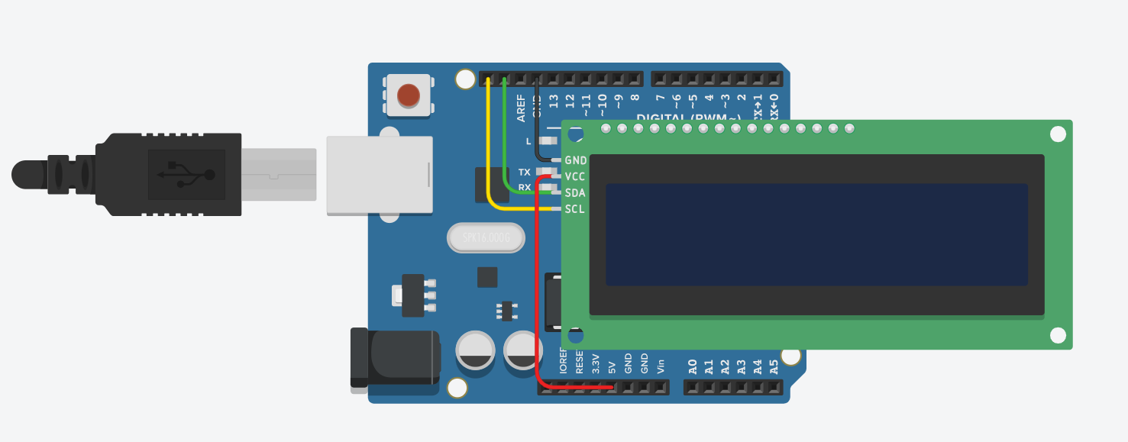

**Code:**

// C++ code

#include <Adafruit_LiquidCrystal.h>

int seconds = 0;

Adafruit_LiquidCrystal lcd_1(0);

void setup()

{

lcd_1.begin(16, 2);

lcd_1.print("MCA Standard");

}

void loop()

{

lcd_1.setCursor(0, 1);

lcd_1.print(seconds);

lcd_1.setBacklight(1);

delay(500); // Wait for 500 millisecond(s)

lcd_1.setBacklight(0);

delay(500); // Wait for 500 millisecond(s)

seconds += 1;

}

**Output:**

